Assignment 2
Assignment 1A:
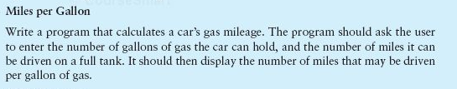
Assignment 1B:
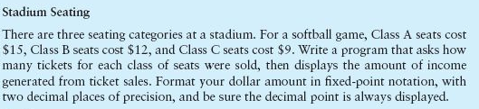
Assignment 2C:
